September 20, 2024

OPPORTUNITIES

SPONSORSHIP & TEAM



**Get your teams together soon! Registration deadline is September 10, 2024.**

Join Utah Food Bank for our first annual **Fore Corners Against Hunger** golf tournament, hosted at Hideout Golf Club in Monticello. San Juan County residents face significantly higher rates of hunger compared to the state average, with 17% reporting food insecurity, as opposed to 10% statewide. Disturbingly, childhood hunger is even more prevalent, with 20% of children uncertain about their next meal, which is double the statewide average. Participating in this event will support our new Southeastern Distribution Center and Utah Food Bank pantries in San Juan County as they make a difference in the lives of southeastern Utahns.

Established in 2001, the Hideout Golf Club (located in the heart of San Juan County) has quickly become one of Utah’s most popular golf courses. Because of its perfect location, the Hideout Golf Club offers a wide range of scenery year-round, as well as perfect golf weather during the season.

This 18-hole course is equipped with many different elevations and each hole will challenge your golf game in ways you never thought.

**WHEN:**

Friday, September 20, 2024

8:00 am – 8:50 am: Breakfast/Check-in

9:00 am: Shotgun Start

TBD: Lunch/Awards Ceremony

**WHERE:**

Hideout Golf Club

648 S. Hideout Way

Monticello, UT 84535

**WHAT:**

Scramble Format (Four-Player Teams)

**COST:**

**Four-Player Team Entry** $400

**Two-Player Team Entry** $200

*Breakfast, lunch, and beverages are included.*

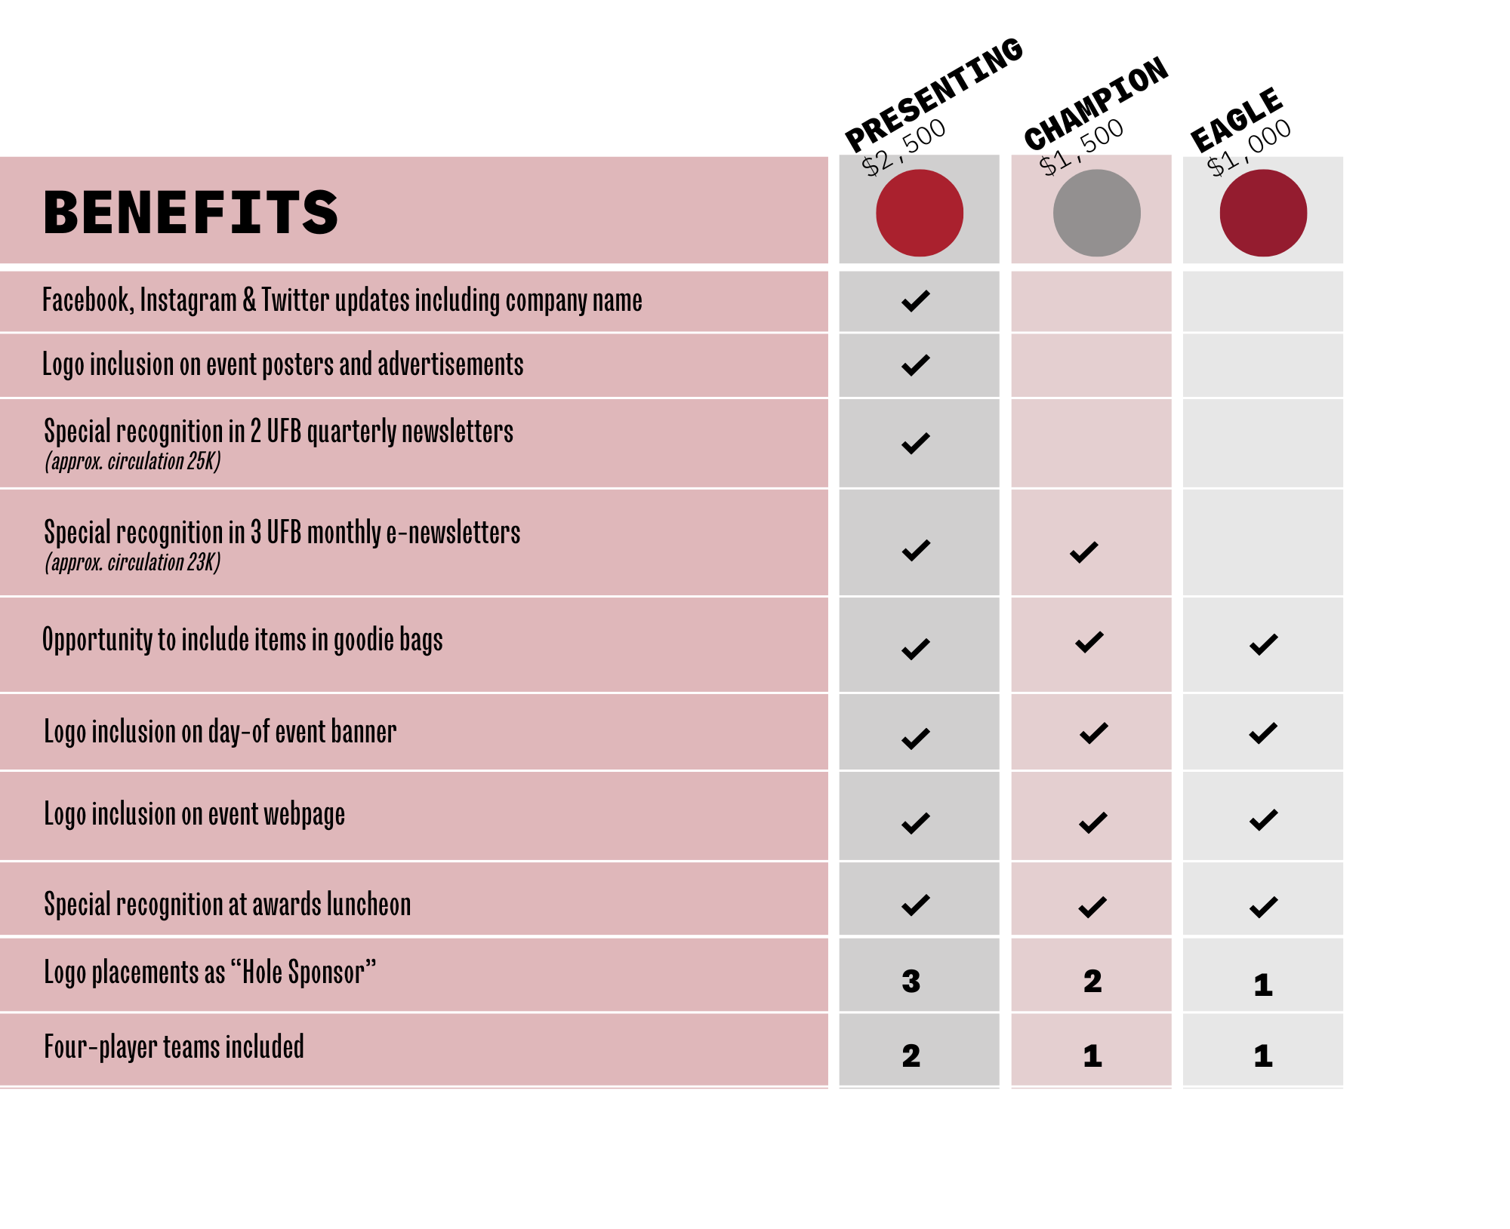

Contact Heidi Cannella at (801) 887-1278 or [heidic@utahfoodbank.org](mailto:heidic@utahfoodbank.org) with questions.

**SPONSORSHIP OPPORTUNITIES**

*Sponsorship deadline is September 1, 2024*

**CORPORATE SPONSOR &**

**Team**

**TEAM REGISTRATION**

Please select your support level:

**$2,500 Presenting $1,500 Champion**

**$1,000 Eagle $300 Four-Player Team $150 Two-Player Team**

**Let’s call it a “mulligan”—I’m sleeping in this year, but still want to donate:** **$**_______________

Primary Contact Name______________________________________________________________________

Phone Number ______________________________Email_________________________________________

Name of Organization ______________________________________________________________________

Mailing Address ___________________________________________________________________________

City/State/Zip _____________________________________________________________________________

**PAYMENT OPTIONS**

Amount $___________________________________ Cash Check Credit Card

**Charge credit card**: VISA AMEX MasterCard Discover

Name as it appears on CC __________________________­­­­­­­_______________ Security Code _____________

CC # ___________________________________________________ Exp. Date _____ /_____ /___________

Billing Address____________________________________________________________________________

**Authorized Signature** ______________________________________________________________________

**Enclosed is a check payable to Utah Food Bank (Check #_______________________________)**

**Invoice Me**

Primary Contact Name______________________________________________________________________

Name of Organization ______________________________________________________________________

Mailing Address ___________________________________________________________________________

City/State/Zip _____________________________________________________________________________

***Please also complete team roster form on following page and return to:***

Utah Food Bank / Attn: Heidi Cannella / 3150 S 900 W, Salt Lake City, UT 84119

[heidic@UtahFoodBank.org](mailto:heidic@UtahFoodBank.org)

***Utah Food Bank is a private, non-profit, 501(c)(3) tax-exempt organization. Tax ID 87-0212453.***



TEAM ROSTER FORM

______________________________________ ______________________________________________

Primary Contact Name Team Name/Company Name

_______________________________________­­­­­­­­­­­­­­­­­­­­­___________________________________________________

Address (Including City, State & Zip Code)

_______________________________________ ________________________________________________

Phone Email

_______________________________________ ________________________________________________

Player One Phone & Email

________________________________________ ________________________________________________

Player Two Phone & Email

________________________________________ ________________________________________________

Player Three Phone & Email

________________________________________ ________________________________________________

Player Four Phone & Email





**RULES OF PLAY**

**SCRAMBLE**

* Blue tees for men and red for women.
* Pick the best tee shot and play from there.
* No improvement in lie, i.e. sand for sand, etc.
* Ball can be moved one club length from the original position with no improvement in lie.

**DRESS CODE**

* Resort casual: jeans and T-shirts permitted as long as they are tasteful.

**ON THE COURSE**

* Beverages will be provided via a beverage cart.
* Please rake bunkers, replace any divots, and repair your ball marks on the greens.

**PACE OF PLAY**

* Maximum possible score per hole is a double bogey. If you are putting for a double bogey, PLEASE PICK UP YOUR BALL AND MOVE ON.
* Please do not spend much time looking for golf balls (3-minute limit).
* Time limit for the round will be 5-6 hours. Should Course Marshall tell you to finish the play, you should score par for all unplayed holes.

**PRIZE HOLES**

* Hole-in-One Challenge: 3
* Closest to the Pin Men: 17
* Closest to the Pin Women: 17
* Longest Drive Men: 9
* Longest Drive Women: 9

**LOCATION**

Hideout Golf Club

648 S. Hideout Way

Monticello, UT 84535